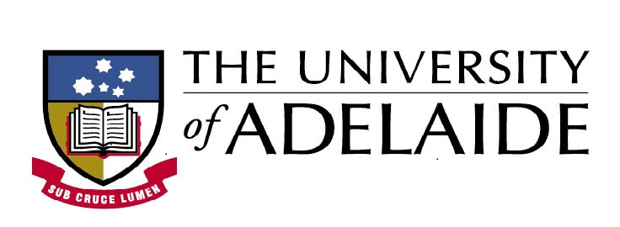

Imagining the Family: An Inheriting the Family Network Event 16–17 April 2020, The University of Adelaide
Draft Programme
Day One
Thursday 16 April - Barr Smith South Room 2040, The University of Adelaide
9.30–9.45am - Arrive and coffee
9.45–10.15am Welcome and acknowledgement of country
10.15am–12.15pm Session 1: Contesting the Family Chair: Ashley Barnwell
- Katie Barclay, Counting the Family: Account Books and Family Identity
- Dolly MacKinnon, Blood Relatives and a Forged Tombstone: Inheriting the 18th-century Meyler Family in Bristol and Jamaica
- Leanne Calvert, Objects of Affection? Imagining the Family through Material Culture

12.15–1.30pm Lunch
1.30–3.30pm Session 2: Imagined Stories
Chair: Tanya Evans
- Anna Green, Imagining Family Relationships: Genealogy and Memory among the Descendants of Nineteenth-Century European Settlers in New Zealand
- Ashley Barnwell, Family History, Settler Time, and Anachronism: Looking at the Photography of Thomas Dick
- Lukasz Krzyzowski, title TBC
3.30–4.00pm Tea break
4.00–4.45pm Group discussion
6pm Dinner for speakers (invitation only)
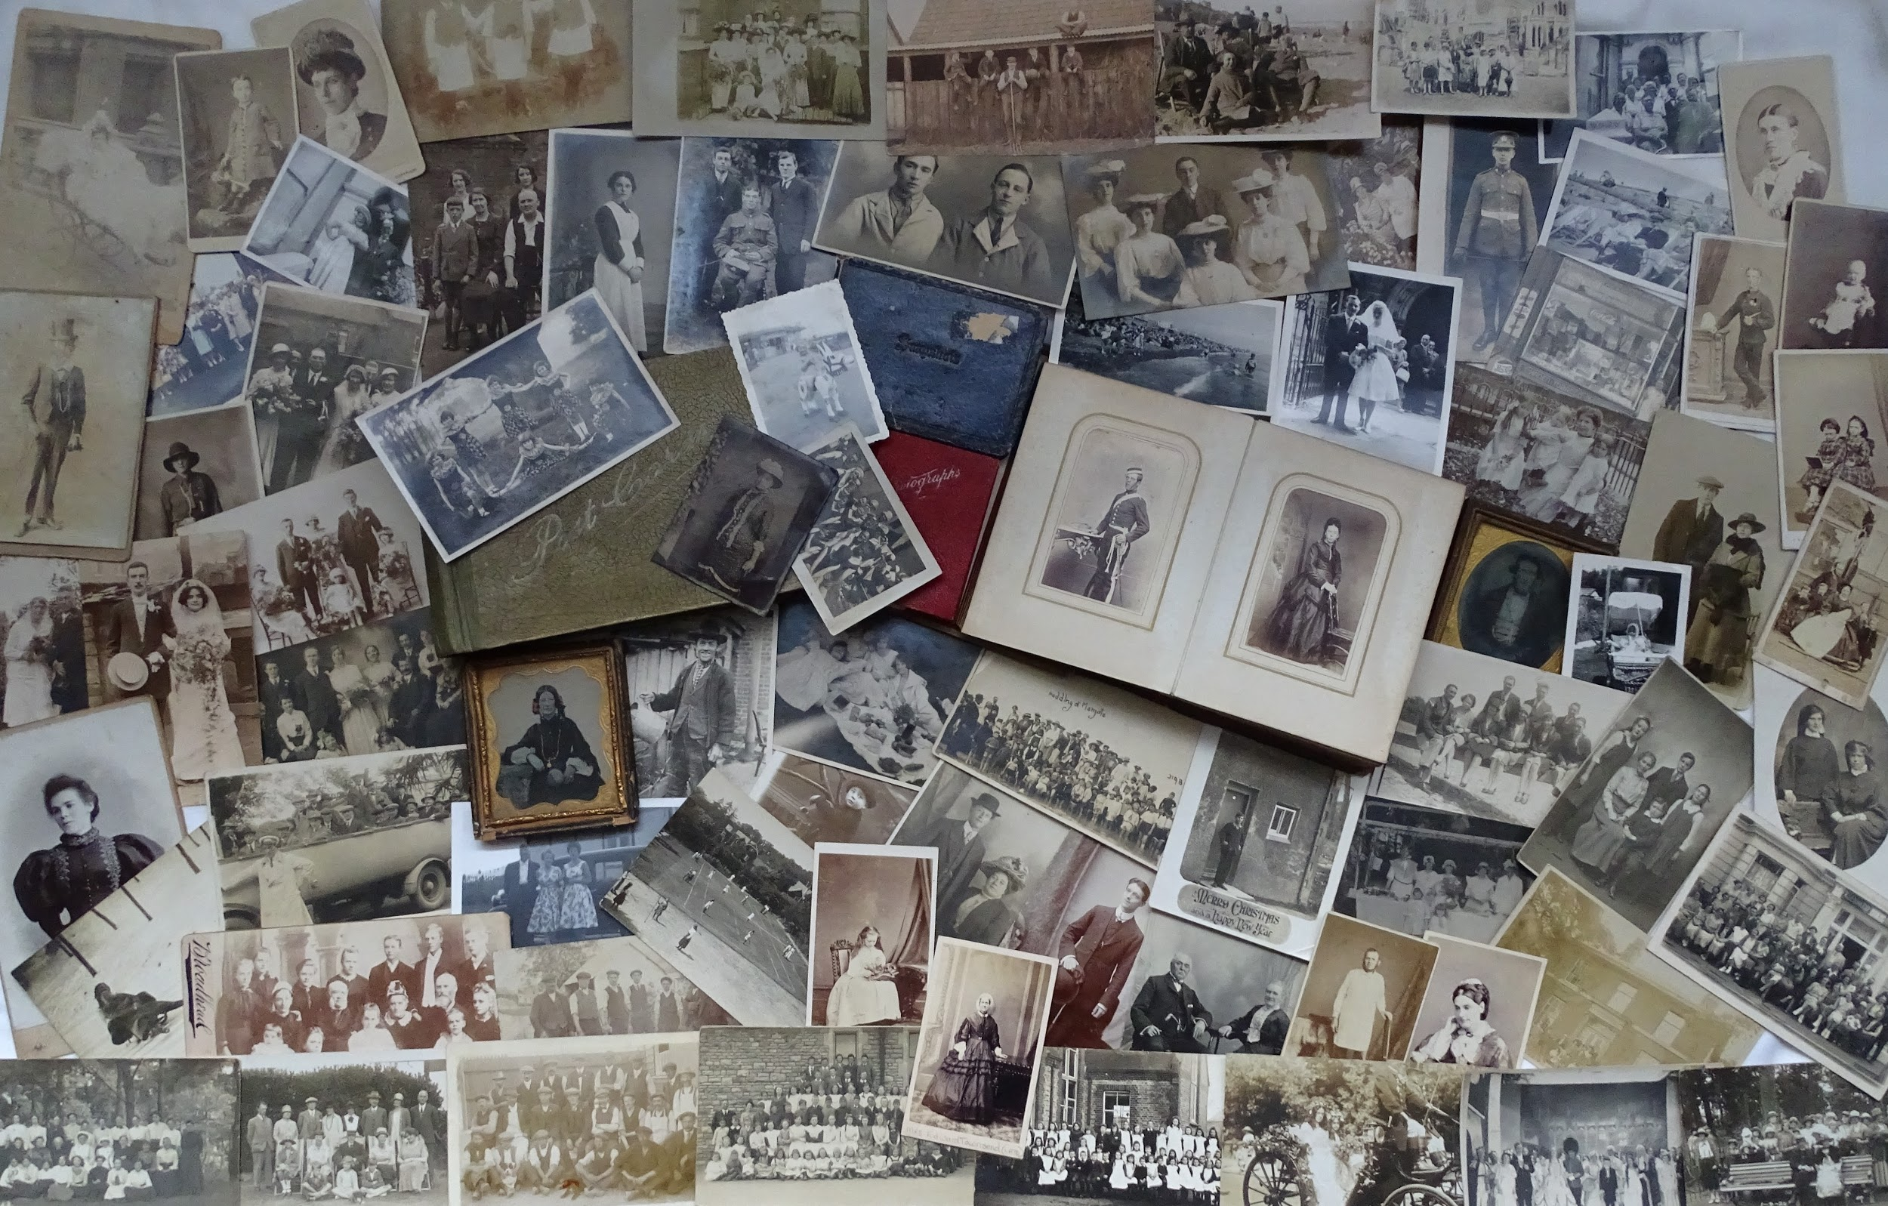
Day Two
Friday 17 April Stretton Room (420), Napier Building, The University of Adelaide
9.45am–10.00am - Arrive and coffee

10.00am–12.00pm - Session 3: Finding Family
- Jenni Caruso, title TBC
- Corrine Ball, Family Ties: Telling the Difficult Stories of Adelaide’s Destitute Asylum
- Jane McCabe, Title TBC
12.00–12.30pm - Closing discussion
12.30–1.30pm - Lunch and workshop close
Note change of venue for the afternoon: Jervois Room, State Library of South Australia
2.00–4.00pm - History Harvest: Family Photographs
4.30–6.30pm - (UK 8am–10am) Steering committee meeting
7.00pm - Steering Committee Dinner

