Numbers and the Self
Friday 1 May 2020
The Stretton Room, Napier Building
The University of Adelaide
Keynote: Deborah Lupton, UNSW
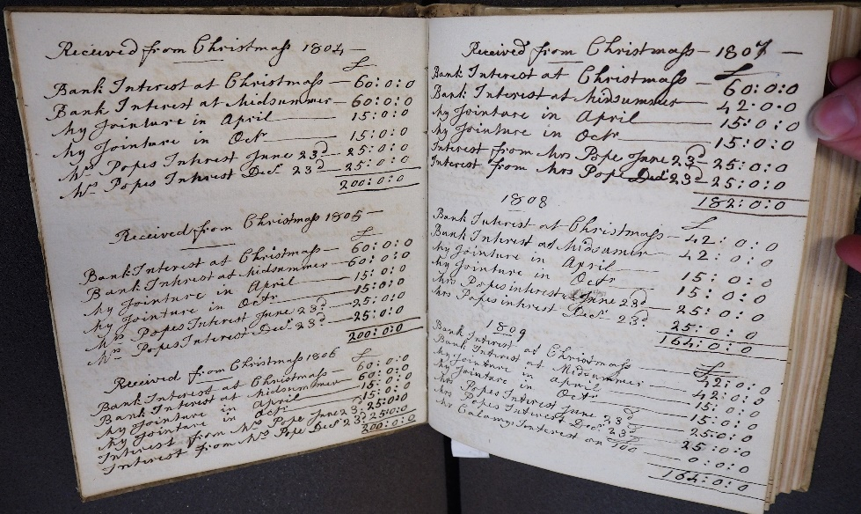
In 1846, the Danish philosopher and social critic Søren Kierkegaard reflected on The Present Age in Europe, where the passions of revolution had been dissolved into measuring systems and ‘everyone is given clever rules and calculators in order to aid one’s thinking’. This ‘quantifying siren song’, as Kierkegaard described it, was alluring in its seeming production of equality for a modern age –it produced a levelling of society, as the individual was collapsed into data. But for him, it came with a loss of ‘passion’, a stagnation in innovation, and an inability to enable significant social, economic or political change. Kierkegaard’s critique resonates with those of contemporary neoliberal regimes and the focus on ‘metrics’ and ‘counting’ as a useful measure of the human and its capacity. Recently, sociologists have also pointed to the ‘quantified self’, new ways of interpreting the human condition produced in relation to self-tracking technologies and metrics. Numbers increasingly surround us and make us, leading us to ask that if writing produces the self – what happens when we count it?

This symposium, funded by an ARC Discovery Project ‘Precarious Accounts’, explores the relationship between numbers and the self as a critical question in the era of big data. Much of contemporary science and social science rests on our reliance that there is a relationship between the human and the number – that our bodies, behaviours and actions, if conceptualised well, can be turned into statistics and used to predict and explain. Because of this numbers can bring us comfort and relief, as well as anxiety and fear. Numbers discipline, with both positive and negative results. They produce certain types of meaning that shapes our social environment. Yet, as Foucault reminded us, numbers never record neutral facts but enable systems of power. This workshop engages with these issues.

Programme

9-930 arrive
930-10 Welcome

10-1115 Keynote, Chair: Katie Barclay
More-than-Human Quantified Selves
Deborah Lupton, UNSW

1115-1145 Tea break

1145-115 Panel 1: Creating with Numbers
Chair: TBC
Sounding Numbers in the Passions of the Soul
Carol J. Williams, Monash
Humanising (Big) Data: Datafication and Determinism
Stephen Abblitt, Keypath Education
Truth and Trust in Public Numbers: The Role of Statisticians in Australian Public Debate
Samantha Vilkins, ANU

115-2 Lunch

2-330 Panel 2: Accounting and the Self
Chair: TBC
Accounting for the Self in a Time of Anxiety and Change: Howell’s Ledger
Heather Dalton, The University of Melbourne
Women, Accounting, and Discipline in the Eighteenth-Century Printed Pocketbook
Elizabeth Spencer, University of York
Numbers Make the Family: Gilbert Innes of Stowe, 1751–1832
Katie Barclay, The University of Adelaide

330-4 Tea break
4-430 Group discussion
430 Close

Abstracts

Sounding numbers in the Passions of the Soul
Carol J. Williams, Monash University

According to the legend it was Pythagoras who first made the connection between numbers and the acoustic relations between musical pitches. He was wandering past a blacksmith’s forge when he was attracted to the ringing tones of the different anvils as they were struck by the hammer. By experimentation he worked out that anvils of particular proportionate weights produced specific intervals, thus anvils in the proportion 2:1 produced the octave, 3:2 the fifth, and 4:3, the fourth. These first numbers, 1, 2, 3 and 4 formed the three fundamental intervals, the structural base on which Western European music and music theory stands. Plato in the Timaeus confirmed that "all nature consists of harmony arising out of numbers" and that the mathematical laws as expressed through music were fundamental not only to our understanding of the world but to human well-being. Boethius translated and transmitted these ideas to the early Middle Ages providing the basis for the thinking around the Harmony of Spheres which was to remain influential in music philosophy beyond the Baroque. In the late 13th and early 14th centuries as a result of the renovation of the Aristotelian oeuvre the connections between numbers, music and the self were further nuanced in the debates around the Passions of the Soul. Guy of St Denis was to develop the thinking of Aquinas, with perhaps the help of Peter of Auvergne, to apply specifically to music so that specific numerical proportions, through the resounding musical interval, could be shown to instigate a specific emotional state.

Carol J. Williams is an Honorary Associate Investigator with the Australian Research Council Centre of Excellence for the History of Emotions. As an adjunct research fellow of the Centre for Medieval and Renaissance Studies of Monash University, she has an established academic career in both musicology and history. She is one of the collaborating editors and translators of the Ars Musice of Johannes de Grocheio (2011) and the Tractatus de tonis of Guy of Saint-Denis (2017). Co-authored articles include “Ancients and moderns in medieval music theory: From Guido of Arezzo to Jacobus” in Intellectual History Review (2017) with Constant Mews and , “New Light on Frater Nicolaus de Aversa: His Plainchant Treatise in LHD 244” in Musica Disciplina (2015) with Karen Cook. Her most recent work is a book chapter “Music and Emotions 1100-1700”, in Routledge History Handbook to Emotions in Europe, 1100-1700 eds Andrew Lynch and Sue Broomhall. She is also a performing musician, singing and playing harp, vielle and rebec in the early music ensemble, Acord.

Humanising (Big) Data: Datafication and Determinism
Stephen Abblitt, Keypath Education

The datafiction of everyday life continues at a relentless pace. The lure and pull of big data is immense: We are presented with endless visions of life and learning made better by big data in any of its current incarnations. Data is increasingly abundant, in often very mundane forms, generated, recorded, stored, processed manipulated and distributed at an unprecedented scale. This technological trend renders aspects of life and learning into data, subsequently processed, quickly sifted and sorted, and translated into information and realised as a new form of value. It frequently goes unnoticed or overlooked, but exerts influence and power, designed or unintended, over our behaviour and thought. Focusing on developments in education, this paper examines the techno-scientific culture of measurement that is being advanced through this datafication, wondering how all this data is changing our understanding of learners and learning. How are such technical developments as algorithmic thinking, artificial intelligence, data mining, machine learning and predictive analytics, reshaping pedagogical practice, educational policy, and institutional strategy?
This paper argues that the datafication and quantification of education reifies an unreliable data-scientific objectivity, to the neglect of other forms of evidence about learners and learning. Examining the effects of algorithms and automated decision-making on the personalisation of education, the learning theories and governance regimes instantiated by machine learning techniques and predictive analytics, and the neuro-biological determinism and genetic essentialism lurking beneath the contemporary learning sciences, it argues that, if unchecked, the sheer volume and velocity of big data—for all the good it can do and is doing to aid our understanding of learning—also threatens to reproduce an outdated determinism which runs counter to contemporary thinking about how learners learn.

Stephen Abblitt (@thepostcritic) is a literary philosopher, queer theorist, and educational researcher. He received his PhD from La Trobe University (Melbourne, Australia) in 2011, and is currently completing his MSc (Digital Education) at the University of Edinburgh (UK). Stephen’s research interests range across literary studies, critical theory, critical-creative writing, gender studies and queer theory, the digital humanities, and postdigital culture and education. His work has been published in peer-reviewed journals including A/B: Autobiography Studies, Higher Education Research and Development, Human Geography, James Joyce Quarterly, Mosaic, TEXT and Writing from Below. He is currently Academic Development Manager with Keypath Education.

Truth and Trust in Public Numbers: The Role of Statisticians in Australian Public Debate
Samantha Vilkins, ANU

The founding tenet of statistics is that they are a science of facts, and not opinion: in 1834 the first statistical society had as its motto the Latin phrase aliis exterendum, ‘to be threshed out by others’. The twin threads of development of our modern statistics, the science of the state in actuarial tables and the statistical science of probabilities, embodied this belief of statistics as sole arbiter of objective knowledge, relying on it to forge individual selves into governable nations via the laws of large numbers. But as Wittgenstein remarked, there is a reason we learn to count as meticulously as we do — just as with language, it is not because numbers are necessarily true, but that they are useful.
Statistics has now become the language of the modern state, through which policy debate, decisions and evaluation is conducted. Once something is measurable, it can matter. Seemingly arbitrary accounts exist for every argument, and the challenges faced by the rise of ‘neutral’ factchecking efforts show us that despite diligent research, veracity often depends on perspective. Despite this, the status of statistics in public debate still holds, reinforced at every stage in their conceptualisation and communication. The heart of this is done in the work of statisticians, those responsible for transmogrifying political pursuits into seemingly objective truth. As they reshape the world in number, to what extent does the aliis exterendum attitude still pervade?
Drawing on a series of interviews, this talk will analyse the prevailing attitudes of those working on public statistics in Australia, where public debate is funnelled through a concentrated media landscape, and trust in national institutions and statistics is high. Who decides what counts? Who is responsible for truth and trust in numbers?

Samantha Vilkins is a PhD candidate in science communication and Communication and Outreach Coordinator at the Australian National Centre for the Public Awareness of Science at The Australian National University in Canberra. Drawing on a background in mathematics and an ungodly fascination with bureaucracy, her current research focuses on the uses of quantified evidence in politics, and what gets left behind by metrics and statistics. She spends equal time despairing and proselytising about new media, social or otherwise, assisting on the ANU Science Communication and the Web course since 2017. Her visual design work has been on display at the National Museum of Australia and the National Library of Australia, and was part of the Science Gallery Melbourne's 2018 PERFECTION exhibit.
She tweets @samvilkins.

Accounting for the Self in a Time of Anxiety and Change: Howell’s Ledger
Heather Dalton, University of Melbourne

The wealthy merchant and London Draper Thomas Howell (c.1480–1537) is known on account of his trading ledger (1517-1528) and the fact that he left by far the biggest sixteenth-century charitable endowment for marriage subsidies. His ledger, deposited with the Drapers' Company during his lifetime, is often cited by historians and economists because it sheds light on Anglo- Spanish trade during the early Tudor period and is reportedly the earliest surviving English example of double-entry bookkeeping.
However, Howell’s ledger is generally only mentioned in passing because scholars have not, for the most part, found hoped for details regarding relationships, new world exploration and exchange. The majority of the 297 pages of Howell’s ledger are, after all, concerned solely with recording profit and loss. Yet, in his final will, dictated to a Spanish notary in 1537 as he lay dying in Seville, Howell harked back to what he called ‘my greate booke’. Although his last entry in the ledger had been made nine years previously, Howell emphasized that the ‘detts that is owing me and that I did owe in shall stande according as it is expressed in the saide testament and none other things’. Howell knew that his lack of progeny and the fact that he was to die in a Catholic country, four years after Henry VIII’s break with Rome, put his legacy in a somewhat precarious position. In my paper I examine Howell’s ‘greate booke’ in the context of his life in order to explore how important it was to Howell that he quantify his life, not just in terms of profit and loss, but in terms of reliability, ensuring that, in lieu of his lack of family, his estate would be used to ensure that the name ‘Howell’ was remembered.

Heather Dalton is an honorary fellow in the School of Historical & Philosophical Studies at the University of Melbourne The focus of her research is relationships in maritime trading networks (1450-1650) AND early contacts between Australasia and Europe. Her recent publications include: Merchants and Explorers: Roger Barlow, Sebastian Cabot and Networks of Atlantic Exchange, 1500 – 1560 (Oxford: Oxford University Press, 2016). In 2020 Amsterdam University Press will publish her edited collection: Keeping Family in an Age of Long Distance Trade, Imperial Expansion and Exile, 1550-1850.

Women, Accounting, and Discipline in the Eighteenth-Century Printed Pocketbook
Elizabeth Spencer, University of York

This paper will look at how women used printed pocketbooks like The Ladies Own Memorandum-Book to keep account in the long eighteenth century. Increasingly available from the mid-century onwards, these small and portable books provided printed templates for recording income and expenditure, as well as space for ‘Memorandums and Remarks’. Scholars have already noted that there is an inherent tension in these texts between consumerism and good economy. Indeed, Jennie Batchelor has argued that the pocketbook’s main significance lies in the fact that the printed text constructed a feminine ideal surrounding ‘frugality, modesty and social and economic restraint’. However, we are often faced with a conundrum when looking at extant examples; though their printed elements emphasise good economy through accounting as a discipline, use of these templates for accounting is frequently patchy in practice. Many women only occasionally used their pocketbooks to account, didn’t use them to account at all, or, as is sometimes the case, used the pages of their pocketbook for something other than their prescribed purpose.
Shifting our focus away from the printed text, this paper instead considers the pocketbook as part of women’s wider accounting processes. Drawing on a range of examples including the pocketbooks of Ann Prest, Elizabeth Inchbald, and Jane Porter, I examine the different ways in which these women used (or did not use) these books to record income and expenditure. I suggest that the pocketbook was one of, rather than the only space in which women could keep account, and might form part of a wider process which could include account ledgers, bills, receipts, and rough drafts, as well other sources such as correspondence and commonplace books. Thinking about the pocketbook in this context can help us better understand why many of these books were not used by women to record numbers and descriptions in the way prescribed by printed template and text.

Elizabeth Spencer is a Lecturer in Eighteenth Century and Public History at the University of York, UK. She completed her PhD in 2018, and her thesis looked at the description of women’s clothing in eighteenth-century England. Her current research explores women and accounting – and women as accountants – across the long eighteenth century, paying particular attention to the intertextual processes involved in this.

Numbers Make the Family: Gilbert Innes of Stowe, 1751-1832
Katie Barclay, University of Adelaide

Gilbert Innes of Stowe, an eighteenth-century Scottish banker, managed his family through an elaborate accounting practice that was to shape not just their fiscal relationships, but their emotional connection. Like accounting in other locations, for some members of his family accounts could be a useful practice to display their effective and frugal discipline of the self; for others they were a tool of discipline that produced significant anxiety, even anger. This paper explores how we might think of account books as sources not just for how we manage money but how we produce social, emotional and ethical relations. It draws primarily on the accounts of Innes of Stowe and his family, but places them within the context of similar accounting practices amongst families of the period. In doing so, I wish to go further that to just think of accounts as a symbol for a set of disciplinary practices but as something to read as a source of the self and the self produced in relation to both others and numbers.

