Numbers and the Self
Friday 1 May 2020
University of Adelaide
Keynote: Deborah Lupton, UNSW
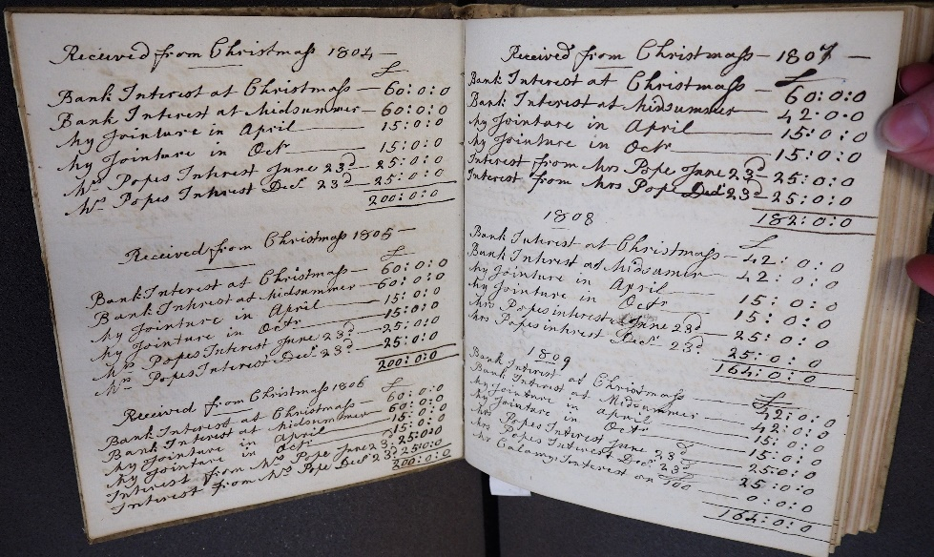
In 1846, the Danish philosopher and social critic Søren Kierkegaard reflected on The Present Age in Europe, where the passions of revolution had been dissolved into measuring systems and ‘everyone is given clever rules and calculators in order to aid one’s thinking’. This ‘quantifying siren song’, as Kierkegaard described it, was alluring in its seeming production of equality for a modern age ⁠—it produced a leveling of society, as the individual was collapsed into data. But for him, it came with a loss of ‘passion’, a stagnation in innovation and an inability to enable significant social, economic or political change. Kierkegaard’s critique resonates with those of contemporary neoliberal regimes and the focus on ‘metrics’ and ‘counting’ as a useful measure of the human and its capacity. Recently, sociologists have also pointed to the ‘quantified self’, new ways of interpreting the human condition produced in relation to self-tracking technologies and metrics. Numbers increasingly surround us and make us, leading us to ask that if writing produces the self ⁠— what happens when we count it?

This symposium, funded by an ARC Discovery Project ‘Precarious Accounts’, explores the relationship between numbers and the self as a critical question in the era of big data. Much of contemporary science and social science rests on our reliance that there is a relationship between the human and the number ⁠—that our bodies, behaviours and actions, if conceptualised well, can be turned into statistics and used to predict and explain. Because of this numbers can bring us comfort and relief, as well as anxiety and fear. Numbers discipline, with both positive and negative results. They produce certain types of meaning that shapes our social environment. Yet, as Foucault reminded us, numbers never record neutral facts but enable systems of power. This workshop engages with these issues. Topics for discussion may include:

Numbers as discipline
Numbers and embodiment
Numbers and emotions – from anxiety to joy
Numbers and self-expression, art and creative practices
Numbers as a philosophy of self
Measuring the abstract and intangible
Numbers, self and society – changing the world?

Proposals for papers, panels or creative responses to this topic are now called for. Please send a 250–300 abstract of what is proposed, the time needed, and short bios of the participants to Katie Barclay at katie.barclay@adelaide.edu.au by the 15 November 2019. All disciplinary perspectives and career stages welcome.

